INVITATION to
SOCIAL SEEDS
2nd Transnational Policy Learning Dialogue

07-08 September 2022 | Rzeszow, Poland

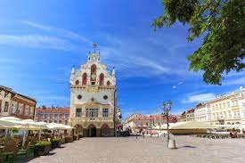

Venue: Grand Hotel Rzeszow,
Dymnickiego Street 1a, 35-030 Rzeszów

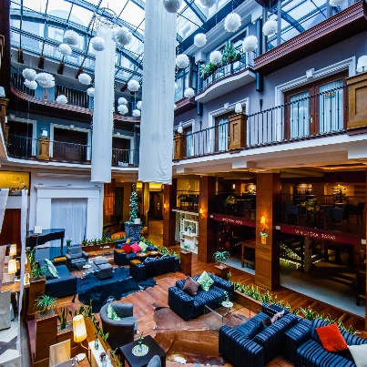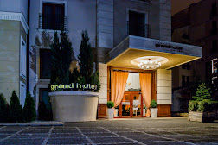
AGENDA

Day 0 (6 Sept.) 19:00 Networking Dinner at Restaurant (venue: tbd)

DAY 1
Venue: Conference Room, Grand Hotel Rzeszow

09:00 - 11:00 | Session 1: Results of mapping 2  - Methodology approach explanation - Miriam Mohr, Steinbeis Europa Zentrum, Germany  - Results of mapping 2 in Hungary- Tamás Szenttamási, IFKA Public Benefit Non-Profit Ltd. for the Development of the Industry, Hungary  - Results of mapping 2 in Poland- Agata Ziemiakowicz, RRDA - Rzeszow Regional Development Agency, Poland  - Results of Mapping 2 in Czechia- Zdeněk Hanzal, RERA - Regional Development Agency of South Bohemia, Czech Republic  - Results of Mapping 2 in Slovenia - Helena Cvenkel, BSC - Business Support Centre Ltd., Kranj, Slovenia  - Results of Mapping 2 in Germany - Miriam Mohr, Steinbeis Europa Zentrum, Germany
11:00 - 11:15 | Coffee break

11:15 - 13:00 | Session 2 : The future of Social Economy after Covid and world crisis caused by pandemic and war in Ukraine  Moderator: Prof. Piotr Zawada- Social Economy Specialist in RRDA  - Introduction- Prof. Piotr Zawada- Social Economy Specialist in RRDA  - The future of Social Sector in Europe - Ms. Roberta d’Ollio- President of EURADA  - Crowdfunding for Social Entities- presentation of pilot action in the frame of OSS Project- Interreg Europe- Mr. Marek Duda- Director of National and International Project and Programmes  - Carpathian Startup Fest – Mr. Dawid Adamski- Manager of the Programme, Director of the Marketing Departament in RRDA Rzeszów  - Input from partners TBD- presentations -  - Moderated discussion on presented topics- Moderator: Prof. Piotr Zawada
13:00 - 14:00 | Lunch break
14:30-15:30  19:30 | Session 3 Study Visits- Local social entities and their experiences with pandemic and refugee crisis  - Innpro Association  More info about this social entity : https://www.goinpro.org/en/  - Social Pub  Social Pub and Brewery is the third social project of Social Cooperative Polifonia Project.  We will hear the story about all the 3 social entities and how the developed through years, how they survived pandemic and how they are working now. The study visit will take place in the permises of Social Pub.  Dinner at Social Pub

DAY 2 Venue: Conference Room, Grand Hotel Rzeszow

09:00 - 11:00 | Best practices: From one crisis to another: Covid and Russian Invasion on Ukraine in Social Enterprises in border countries  SPEAKRES TBD  Marek Piechuta - Head and founder of Dobry Dom Association –presentation on Social Therapy Worskshops operation during the pandemic and help for Ukrainian Refugees – Podkarpackie  Project Partners Presentations TBD  Project Partners  Project Partners
11:00-11:15 | Coffee break
11:15 - 13:00 | SOCIAL SEEDS project partners’ meeting  Only for project partners, stakeholders will have free time.
13:00 - 14:00 | Lunch & farewell  Venue: Restaurant, Grand Hotel Rzeszow.

